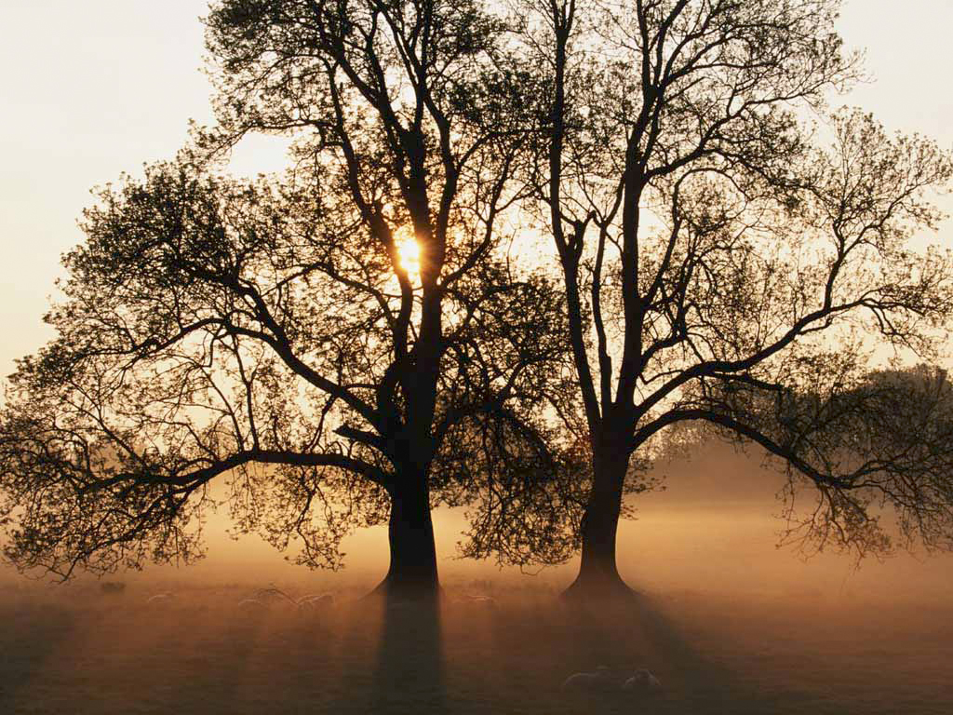

Adult Sunday School

December 16, 2007

Tree of Life

TEXT: Revelation 22:14

- There is a Rule for all Things

- God Assigns the Limits
Genesis 2:9, 16, 17

- We must walk in the line of duty.
2:16 “the Lord God commanded the man”

- A Tree of Life
- Obedience 2:9, 16
- Endless Life 3:22

- The Tree of Knowledge of Good & Evil
- Disobedience 2:17; 3:6
- Death 2:17

- The Tree of Life is a symbol for obedience.
- Believers Right to the Tree of Life

- “Do His Commandments”
Revelation 22:14

- Blessed (happy) are the Obedient
- Authority to the Obedient (“right”)
- In the sense of the ability that God gives. I Peter 4:11
- It’s in receiving the Son. John 1:12
- This is a covenant right. John 14:21, 23

- The Unbelievers & the Disobedient will be Left Without
Revelation 21:7; 22:15

- Dogs of Society
A wild dog is a symbol for roaming around, or being mean, savage, dirty, immoral or undisciplined.
Deut. 23:18; Phil. 3:2, 3

- Sorcerers
Those who engage in astrology, witchcraft, devil worship, spiritism, séances, palm reading, fortune telling.

- Whoremongers
The immoral, sexually impure, fornication, adultery, homosexuality, and those who look & lust, read & lust, and think & lust.

- Murderers
- Take Others Lives
- Suicide
- Abortion
- Hateful I John 3:15

- Idolaters
Those who worship idols which can be anything you give primary attention to.
I Cor. 10:14; Gal. 5:19-21; Eph. 5:5; Col. 3:5-6; Rev. 21:8

- Liars
Loving and making lies and dealing with that which is false.
Rev. 21:8,27; John 8:44; II Thess. 2:12; I John 1:6; Rom. 1:25; Eph. 4:25

